PAAVAI ENGINEERING COLLEGE
(Autonomous)

DEPARTMENT OF ECE

EC 16203
CIRCUITS AND DEVICES LABORATORY MANUAL

EC 16203 CIRCUITS AND DEVICES LABORATORY

LIST OF EXPRIMENT:

- Verification of KVL and KCL
- Verification of Thevenin and Norton Theorems
- Verification of superposition Theorem
- Verification of Maximum power transfer and reciprocity theorems
- Frequency response of series and parallel resonance circuits
- Characteristics of PN and Zener diode
- Characteristics of CE configuration
- Characteristics of CB configuration
- Characteristics of UJT and SCR
- Characteristics of JFET and MOSFET
- Characteristics of Diac and Triac
- Characteristics of Photodiode and Phototransistor

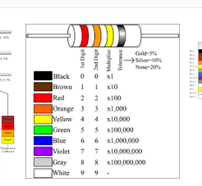
KIRCHOFF’S VOLTAGE LAW
EX. NO: 1(a)
AIM:

To verify the Kirchoff’s Voltage Law (KVL) for the given circuit. APPARATUS REQUIRED:
S.NO | APPARATUS | TYPE | RANGE | QUANTITY
1 | RPS | DC | (0-30)V | 1
2 | Resistor | - | 1KΩ | 3
3 | Voltmeter | DC | (0-10)V | 3
4 | Bread board | - | - | 1
5 | Connecting wires | - | - | Few

FORMULA USED:

1. CURRENT DIVISION RULE:

I = TOTAL CURRENT X OPPOSITE RESISTANCE TOTAL RESISTANCE

2. OHM’S LAW:

V=IR

Where,

V = Voltage in Volts

I = Current in Amperes

R = Resister in Ohms

KIRCHOFF’S VOLTAGE LAW:

It states that the algebraic sum of all the voltages in a closed loop is equal to zero.
∑V = 0

CALCULATION:

= 1K = 1K ; = 1K

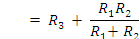
Let V = 5V,

I1= I*R2 R1+R2

V1=I1*R1
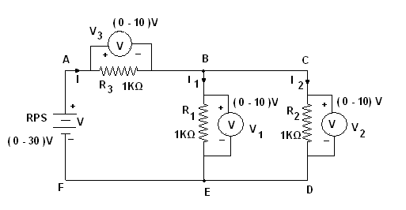
In the loop ABEFA,

Circuit Diagram for Kirchoff’s Voltage Law

PROCEDURE:

KIRCHOFF’S VOLTAGE LAW:

1. The circuit connections are given as per the circuit diagram.
2. Switch ON the power supply.
3. Initially set 5V as input voltage from RPS.

4. The voltmeter readings are noted and the values are tabulated.
5. The same procedure is repeated for various values.

Table:

Supply voltage |  | Resistance in Ohms |  |  |  | Voltage in Volts |  |  | V = V1 + V3
Supply voltage |  | R1 | R2 | R3 | RT | V1 | V2 | V3 | V = V1 + V3
 | Theoretical
 | Practical
 | Theoretical
 | Practical

RESULT:

Thus the Kirchhoff’s Voltage Law (KVL) for the given circuit is verified.

KIRCHOFF’S CURRENT LAW

EX. NO: 1(b)

AIM:

To verify the Kirchoff’s Current Law (KCL) for the given circuit.
APPARATUS REQUIRED:
S.NO | APPARATUS | TYPE | RANGE | QUANTITY
1 | RPS | DC | (0-30)V | 1
2 | Resistor | - | 1KΩ | 3
3 | Ammeter | DC | (0-30)mA | 3
4 | Bread board | - | - | 1
5 | Connecting wires | - | - | Few

FORMULA USED:

1. CURRENT DIVISION RULE:

I = TOTAL CURRENT X OPPOSITE RESISTANCE TOTAL RESISTANCE

2. OHM’S LAW:

Where, V = Voltage in Volts

I = Current in Amperes R = Resister in Ohms

THEORY:
KIRCHOFF’S CURRENT LAW:
It states that the algebraic sum of the currents meeting at a node is equal to zero.

CALCULATION:

= 1K = 1K ; = 1K

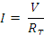
Let V = 5V,

I1= I*R2 R1+R2

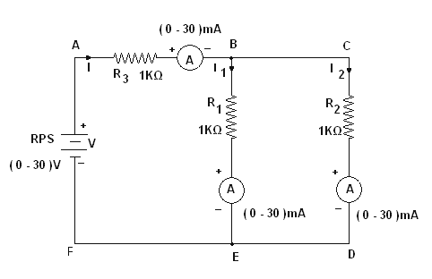
At node B the current = I=I1+I2

Circuit Diagram for Kirchoff’s Current Law PROCEDURE:
KIRCHOFF’S CURRENT LAW:

1. The circuit connections are given as per the circuit diagram.
2. Switch ON the power supply.
3. Initially set 5V as input voltage from RPS.

4. The ammeter readings are noted and the values are tabulated.
5. The same procedure is repeated for various values.

Table:

Supply voltage |  | Resistance in Ohms |  |  |  | Current in mA
Supply voltage |  | R1 | R2 | R3 | RT | I | I1 | I2 | I = I1+I2
 | Theoritical
 | Practical
 | Theoritical
 | Practical

RESULT:

Thus the Kirchoff’s Current Law (KCL) for the given circuit is verified.

THEVENIN’S THEOREM

EX. NO: 2(a)

AIM:
To verify the Thevenin’s theorem for the given circuit.

APPARATUS REQUIRED:

S.NO | APPARATUS | TYPE | RANGE | QUANTITY
1 | RPS | DC | (0-30)V | 1
2 | Resistor | - | 1KΩ | 3
3 | Ammeter | DC | (0-10)mA | 1
4 | Bread board | - | - | 1
5 | Connecting wires | - | - | Few

THEORY:
THEVENIN’S THEOREM:

Any linear active network with output terminals C and D can be replaced
by a single voltage source (VTh = VOc) in series with a single impedance (ZTh =
Zi). VTh is the Thevenin’s voltage. It is the voltage between the terminals C and D on open circuit condition. Hence it is called open circuit voltage denoted by VOc.
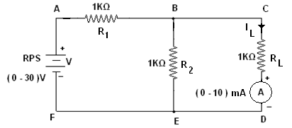
ZTh is called Thevenin’s impedance. It is the driving point impedance at the terminals C and D when all the internal sources are set to zero. In case of DC ZTh is replaced by RTh.

Circuit Diagram for Thevenin’s Theorem

CALCULATION:

The Thevenin’s equivalent circuit is,

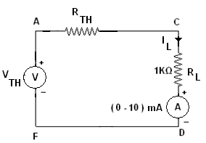
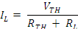
To Find RTH:

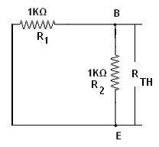
= 1K = 1K;

RTH =R1*R2
R1+R2

To Find VTH:

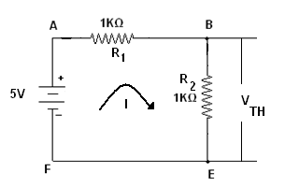

Let V = 5V,

VTH=VBE

PROCEDURE:

1. The circuit connections are given as per the circuit diagram.
2. Switch ON the power supply.
3. Initially set 5V as input voltage from RPS.

4. The ammeter reading is noted and the value is tabulated.

Table:

Supply voltage |  | I_{L} (mA) | V _{th}(volts) | Rth(ohms) | I_{L}’(mA)
 | Theoritical
 | Practical
 | Theoritical
 | Practical

RESULT:

Thus the Thevenin’s theorem for the given circuit is verified successfully.

NORTON’S THEOREM

EX. NO: 2(b)

AIM:
To verify the Norton’s theorem for the given circuit.

APPARATUS REQUIRED:

S.NO | APPARATUS | TYPE | RANGE | QUANTITY
1 | RPS | DC | (0-30)V | 1
2 | Resistor | - | 1KΩ | 3
3 | Ammeter | DC | (0-10)mA | 1
4 | Bread board | - | - | 1
5 | Connecting wires | - | - | Few

THEORY:
NORTON’S THEOREM:

1.Any linear active network with output terminals C and D can be replaced

by a single current source I_{SC}(I_{N}) in parallel with a single impedance (Z_{Th} = Z_{n}).

2.I_{SC} is the current through the terminals C and D on short circuit condition. Z_{Th} is called Thevenin’s impedance. In case of DC Z_{Th} is replaced by R_{Th}.
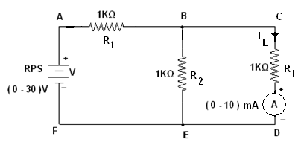
3.The current through impedance connected to the terminals of the Norton’s equivalent circuit must have the same direction as the current through the same impedance connected to the original active network.

Circuit Diagram for Norton’s Theorem

CALCULATION:

The Norton’s equivalent circuit is,

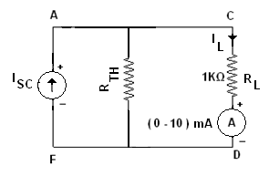
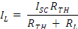
To Find R_{TH}:

= 1K = 1K ;

R_{TH}=R1R2
R1+R2

To Find I_{SC}:

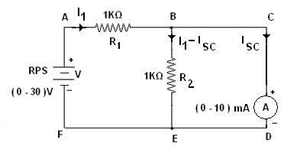

Let V=5V

In the loop ABEFA by applying KVL,

In the loop BCDEB by applying KVL,

From the equation (I) and (2),

∴

I_{L}=Isc *R_{TH}
R_{TH} + R_{L}

PROCEDURE:

1. The circuit connections are given as per the circuit diagram.
2. Switch ON the power supply.
3. Initially set 5V as input voltage from RPS.

4. The ammeter reading is noted and the value is tabulated.
Table:

Supply voltage |  | I_{L} (mA) | I_{SC} (mA) | Rth(ohms) | I_{L}’(mA)
 | Theoritical
 | Practical
 | Theoritical
 | Practical

RESULT:

Thus the Norton’s theorem for the given circuit is verified successfully.
YARTHIPLUS.COM
SUPERPOSITION THEOREM

EX. NO: 3

AIM:
To verify the superposition theorem for the given circuit.

APPARATUS REQUIRED:

S.NO | APPARATUS | TYPE | RANGE | QUANTITY
1 | RPS | DC | (0-30)V | 2
2 | Resistor | - | 1KΩ | 3
3 | Ammeter | DC | (0-10)mA | 1
4 | Bread board | - | - | 1
5 | Connecting wires | - | - | Few

THEORY:

SUPERPOSITION THEOREM:

The superposition theorem for electrical circuits states that the total current in any branch of a bilateral linear circuit equals the algebraic sum of the currents produced by each source acting separately throughout the circuit.

To ascertain the contribution of each individual source, all of the other sources first must be "killed" (set to zero) by:

1. Replacing all other voltage sources with a short circuit (thereby eliminating

Difference of potential. i.e. V=0)

2. Replacing all other current sources with an open circuit (thereby eliminating current. i.e. I=0)

This procedure is followed for each source in turn, and then the resultant currents are added to determine the true operation of the circuit. The resultant circuit operation is the superposition of the various voltage and current sources.RTHIPLUS.COM

E1 and E2 SOURCES ARE ACTING:

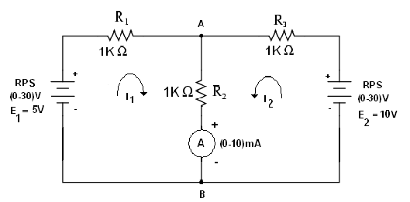
Circuit Diagram for Superposition Theorem

Table:

E1  voltage(Volts) | E2 | Load current across the branch AB (mA)
E1  voltage(Volts) | voltage(Volts) | Theoritical | Practical

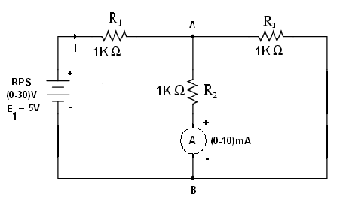
E1 SOURCE IS ACTING:W.VIDYARW.VIDYARTHIPLUS.COM

CALCULATION:

= 1K = 1K ; = 1K

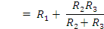
Let V = 5V,

Table:

E1 voltage(Volts) | Load current across the branch AB (mA)
E1 voltage(Volts) | Theoritical | Practical

E2 SOURCE IS ACTING:

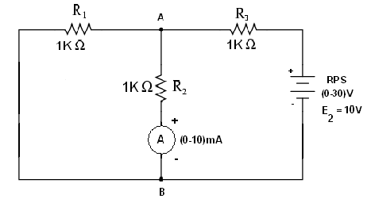

DYARTHIPLUS.COM

CALCULATION:

= 1K = 1K ; = 1K

Let V = 10V,

Table:

E2 voltage(Volts) | Load current across the branch AB (mA)
E2 voltage(Volts) | Theoritical | Practical

RESULT:

Thus the superposition theorem for the given circuit is verified.

MAXIMUM POWER TRANSFER THEOREM

EX. NO: 4(a)

AIM:
To verify the maximum power transfer theorem for the given circuit.

APPARATUS REQUIRED:

S.NO | APPARATUS | TYPE | RANGE | QUANTITY
1 | RPS | DC | (0-30)V | 1
2 | Resistor | - | 1KΩ | 2
3 | Variable Resistor |  | 1KΩ | 1
4 | Ammeter | DC | (0-10)mA | 1
5 | Bread board | - | - | 1
6 | Connecting wires | - | - | Few

THEORY:

MAXIMUM POWER TRANSFER THEOREM:

YARTHIPLUS.COM

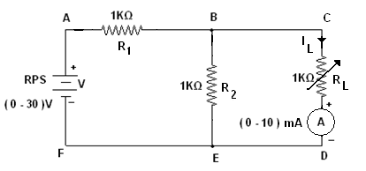
Circuit Diagram for Maximum Power Transfer Theorem

CALCULATION:
To Find R_{TH}:

= 1K = 1K ;
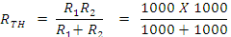

To Find V_{TH}:

YA
Let V = 5V,

PROCEDURE:
1. The circuit connections are given as per the circuit diagram.
2. Switch ON the power supply.
3. Initially set 5V as input voltage from RPS.

4. The ammeter reading is noted for various values of load resistance and the values are tabulated.
5. The load resistance for the maximum power is obtained from the table.

Table:

Supply voltage |  | R_{L}(ohms) | I_{L} (mA) | Power=I_{L}²R_{L} | V _{th}(volts) | P=Vth²/4R_{L}
 | Theoritical
 | Practical
 | Theoritical
 | Practical

RESULT:

Thus the maximum power transfer theorem for the given circuit is verified successfully.
US.CO

MRECIPROCITY THEOREM

EX. NO: 4(b)

AIM:
To verify the reciprocity theorem for the given circuit.

APPARATUS REQUIRED:

S.NO | APPARATUS | TYPE | RANGE | QUANTITY
1 | RPS | DC | (0-30)V | 1
2 | Resistor | - | 1KΩ | 4
3 | Ammeter | DC | (0-5)mA | 1
4 | Bread board | - | - | 1
5 | Connecting wires | - | - | Few

THEORY:
RECIPROCITY THEOREM:

The reciprocity theorem states that if an emf ‘E’ in one branch of a reciprocal network produces a current I in another, then if the emf ‘E’ is moved from the first to the second branch, it will cause the same current in the first branch, where the emf has been replaced by a short circuit. We shall see that any network composed of linear, bilateral elements (such as R, L and C) is reciprocal.

Before interchanging:

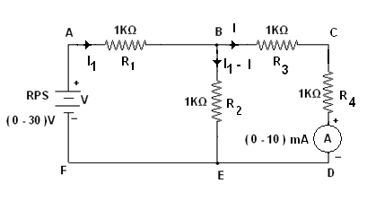
Circuit Diagram for Reciprocity Theorem

.VIDYARTHIPLUS.COM

CALCULATION: Let V=5V
In the loop ABEF by applying KVL,

In the loop BCDE by applying KVL,

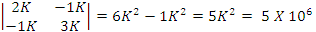
D =

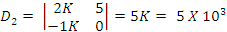
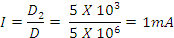
PROCEDURE:

1. The circuit connections are given as per the circuit diagram.
2. Switch ON the power supply.
3. Initially set 5V as input voltage from RPS.

4. The ammeter reading is noted and tabulated.

Table for before interchanging:

V (Volts) | Current (mA)
V (Volts) | Theoritical | Practical

WW.VIDYARTHIPLUS.COM V+ TEAM
WWW.VIDYARTHIPLUS.COM

After interchanging:

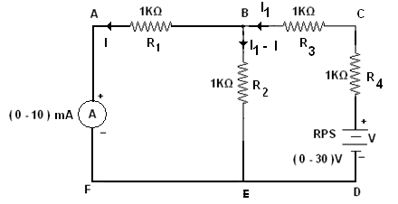

Circuit Diagram for Reciprocity Theorem

CALCULATION: Let V=5V.
In the loop ABEFA by applying KVL,

In the loop BCDE B by applying KVL,

D =

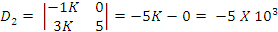
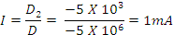
LUS.COM
ROCEDURE:

1. The circuit connections are given as per the circuit diagram.
2. Switch ON the power supply.
3. Initially set 5V as input voltage from RPS.

4. The ammeter reading is noted and tabulated.

Table for before interchanging:

V (Volts) | Current (mA)
V (Volts) | Theoritical | Practical

RESULT:

Thus the reciprocity theorem for the given circuit is verified successfully.

FREQUENCY RESPONSE OF RESONANCE CIRCUIT

EX. NO: 5

AIM:
To analyze the frequency response of series and parallel resonance circuits.
APPARATUS REQUIRED:

S.NO | APPARATUS | TYPE | RANGE | QUANTITY
1 | Function  Generator | AC | (1Hz-  3MHz) | 1
2 | Resistor | AC | 600Ω | 1
3 | Inductor | AC | 101.4mH | 1
4 | Capacitor | AC | 0.01mF | 1
5 | Ammeter | AC | (0-10)mA | 1
6 | Bread board | - | - | 1
7 | Connecting wires | - | - | Few

THEORY:

The resonance of a RLC circuit occurs when the inductive and capacitive reactance are equal in magnitude but cancel each other because they are 180 degrees apart in phase. The sharp minimum in impedance which occurs is useful in tuning applications. The sharpness of the minimum depends on the value of R.

The frequency at which the reactance of the inductance and the

capacitance cancel each other is the resonant frequency (or the unity power factor frequency) of this circuit. This occurs at

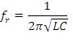

SERIES RESONANCE:

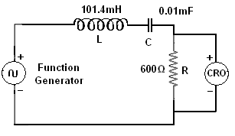
Circuit Diagram for Series Resonant

CALCULATION: R = 600Ω
L = 101.4mH C = 0.01µF

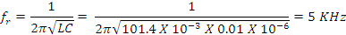
PROCEDURE:

1. The circuit connections are given as per the circuit diagram.
2. Switch ON the power supply.
3. The input is given in the form of sin wave by function generator.
4. The amplitude of the response across the resistor is noted for various frequency ranges.

5. The current is calculated and tabulated.
ARTHIPLUS.COM

Table:

S.NO | Frequncy (KHz) | Output voltage (Volts) | I = V / R (mA)

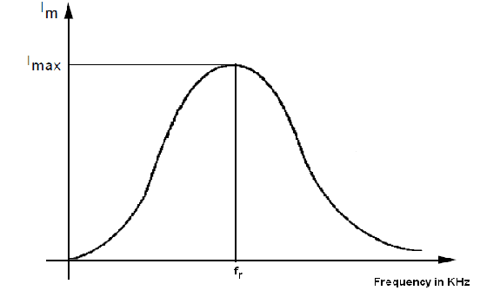
Frequency Response of Series Resonance Circuit

COM

PARALLEL RESONANCE:

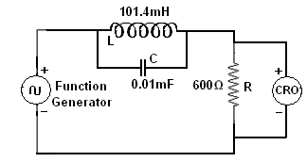

CALCULATION: R = 600Ω
L = 101.4mH C = 0.01µF

PROCEDURE:

1. The circuit connections are given as per the circuit diagram.
2. Switch ON the power supply.
3. The input is given in the form of sin wave by function generator.

4. The amplitude of the response across the resistor is noted for various frequency ranges.
5. The current is calculated and tabulated.

Table:

Frequency (KHz) | Output voltage (Volts) | I = V / R (mA)

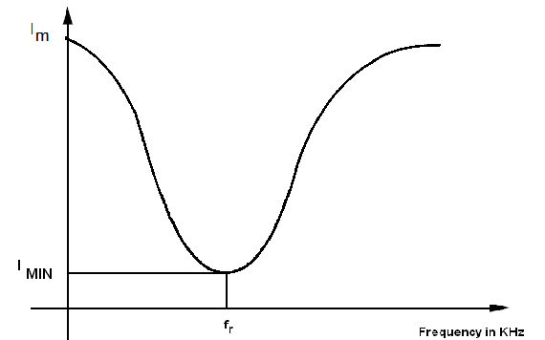

Frequency Response of Parallel Resonance Circuit

RESULT:

Thus the frequency response of series and parallel resonant circuits are analyzed.

WWWARTHIPLUS.COMCHARACTERISTICS OF PN DIODE
EX. NO:6(a)
AIM:
To determine the forward and reverse characteristics of a PN diode.
APPARATUS REQUIRED:
S.NO | APPARATUS | RANGE | QUANTITY
1 | RPS | (0-30)V | 1
2 | Resistor | 220Ω | 1
3 | DC Voltmeter | (0-1)V | 1
4 | DC Ammeter | (0-100)mA | 1
5 | Diode | IN4007 | 1
6 | Bread board | - | 1
7 | Connecting wires | - | Few

At higher currents the forward voltage drop of the diode increases. A drop

of 1 V to 1.5 V is typical at full rated current for power diodes.

V-I Characteristic equation or diode current equation is,

Where,

WWW.VIDYARTHIPLUS.COM

V = Applied voltage

𝛈 = Efficiency (1 for germanium diode; 2 for silicon diode)
VT = voltage equivalent of temperature in volts

V+ TEAM

WWW.VIDYARTHIPLUS.COM

= kT volts
Where, k = Boltzmann’s constant = 8.62 X 10-5 eV/0K T = Temperature in 0K

At room temperature of 270C, T = 27 + 273 = 300 0K
∴ VT = 8.62 X 10-5 X 300 = 25.86 mV

SYMBOL OF

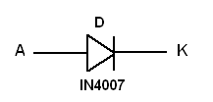
SEMICONDUCTOR DIODE:

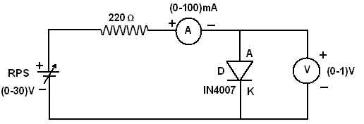
FORWARD BIAS CHARACTERISTICS:

Circuit Diagram for Forward Bias PROCEDURE:
1. Connections are given as per the circuit diagram.
2. Power supply is switched ON.
3. By varying the RPS, the forward current is noted for various forward Voltages.

4. The plot is drawn between the Forward voltage and Forward current.
5. From the plot the forward resistance is calculated.

THIPLUS.COM

Table for Forward Bias:
S.No | Forward Voltage Vf (mV) | Forward Current If (mA)
1

2

3

4

5

6

7

8

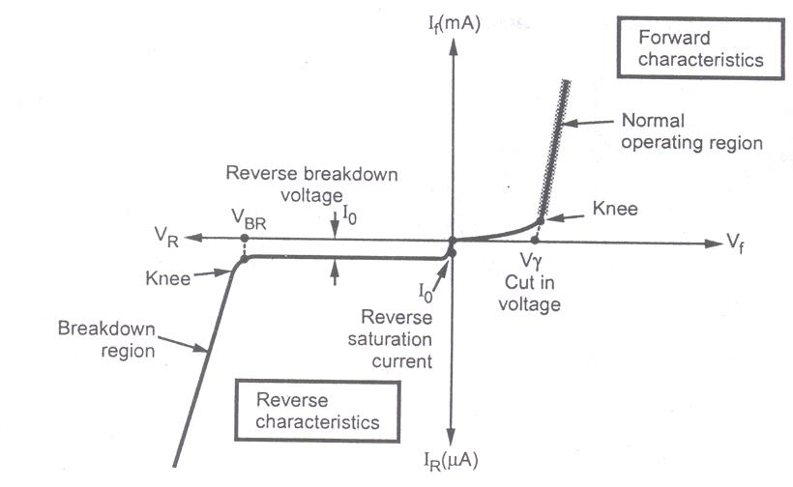
MODEL GRAPH:

V-I Characteristics of a PN Diode

CALCULATION:
Forward resistance,

YARTHIPLUS.COM

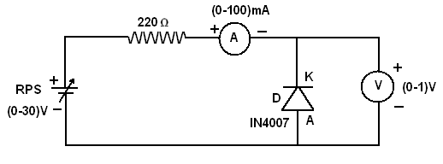
REVERSE BIAS CHARACTERISTICS:

Circuit Diagram for Reverse Bias PROCEDURE:
1. Connections are given as per the circuit diagram.
2. Power supply is switched ON.
3. By varying the RPS, the reverse current is noted for various reverse voltages.

4. The plot is drawn between the reverse voltage and reverse current.
5. From the plot the reverse resistance is calculated.

Table for Reverse Bias:

S.No | Reverse Voltage Vr (mV) | Reverse Current Ir (mA)
1

2

3

4

5

6

7

8

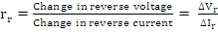
RTHIPLUS.COM

CALCULATION:

(i) Reverse resistance,

RESULT:
Thus the V-I characteristics of a PN diode is drawn for both forward and reverse bias condition.

THIPLUS.COM

CHARACTERISTICS OF ZENER DIODE

EX. NO: 6(b)

AIM:
To determine the forward and reverse characteristics of a zener diode.

APPARATUS REQUIRED:

S.NO | APPARATUS | RANGE | QUANTITY
1 | RPS | (0-30)V | 1
2 | Resistor | 220Ω | 1
3 | DC Voltmeter | (0-1)V | 1
4 | DC Ammeter | (0-100)mA | 1
5 | Zener Diode | IN4730 | 1
6 | Bread board | - | 1
7 | Connecting wires | - | Few

THEORY:

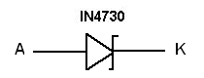
SYMBOL OF ZENER DIODE:

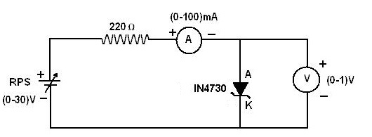
FORWARD BIAS CHARACTERISTICS:

Circuit Diagram for Forward Bias PROCEDURE:
1. Connections are given as per the circuit diagram.

2. Power supply is switched ON.

3. By varying the RPS, the forward current is noted for various forward voltages.
4. The plot is drawn between the Forward voltage and Forward current. 5. From the plot the forward resistance is calculated.
YARTHIPLUS.COM

Table for Forward Bias:

S.No | Forward Voltage Vf (mV) | Forward Current If (mA)
1

2

3

4

5

6

7

8

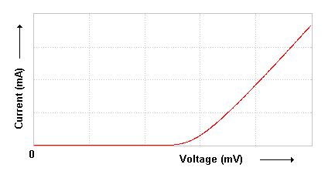
MODEL GRAPH:

Forward Characteristics of a Zener Diode

CALCULATION:
Forward resistance,

VIDYARTHIPLUS.COM

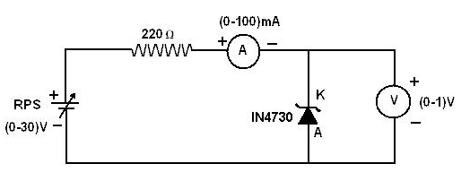
REVERSE BIAS CHARACTERISTICS:

Circuit Diagram for Reverse Bias

PROCEDURE:

1. Connections are given as per the circuit diagram. 2. Power supply is switched ON.
3. By varying the RPS, the reverse current is noted for various reverse voltages.
4. The plot is drawn between the reverse voltage and reverse current. 5. From the plot the reverse resistance is calculated.

Table for Reverse Bias:

S.No | Reverse Voltage Vr (mV) | Reverse Current Ir (mA)
1

2

3

4

5

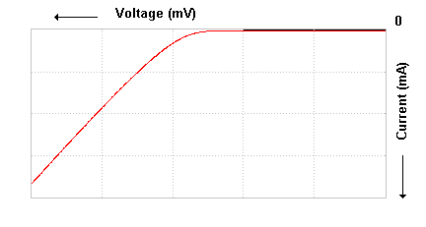
MODEL GRAPH:

Reverse Characteristics of a Zener Diode

CALCULATION:

Reverse resistance,

RESULT:
Thus the V-I characteristics of a Zener diode is drawn for both forward and reverse bias condition.

RTHIPLUS.COM

EX.NO:7 CHARACTERISTICS OF BJT IN CE CONFIGURATION
AIM:

To plot the input and output characteristics of a bipolar junction transistor (BJT) in common emitter (CE) configuration.

APPARATUS REQUIRED:

S.NO | APPARATUS | RANGE | QUANTITY
1 | RPS | (0-30)V | 2
2 | Resistor | 1KΩ | 2
3 | DC Voltmeter | (0-30)V | 1
4 | DC Voltmeter | (0-10)V | 1
5 | DC Ammeter | (0-50)µA | 1
6 | DC Ammeter | (0-30)mA | 1
7 | BJT | BC547 | 1
8 | Bread board | - | 1
9 | Connecting wires | - | Few

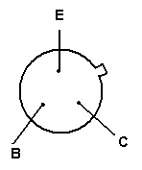
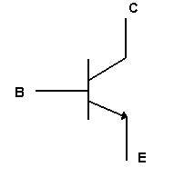
THEORY:

PLUS.COM

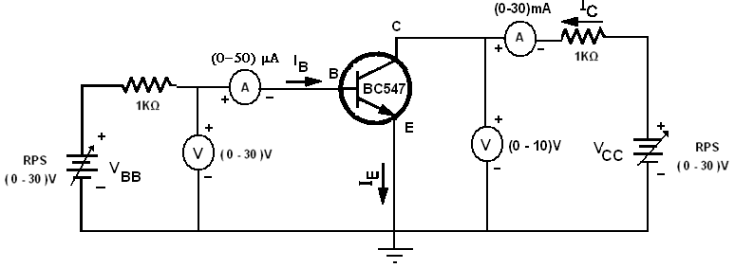
Circuit Diagram for a BJT in CE Configuration

INPUT CHARACTERISTICS:

PROCEDURE:

1. Connections are given as per the circuit diagram.

2. The supply is switched ON.

3. The collector-emitter voltage VCE is kept constant.

4. By varying the emitter-base voltage VBE, the various base current IB is noted.
5. The same procedure is repeated for various collector-emitter voltages VCE.
6. The input characteristic is the curve between input current IB and input voltage VBE at constant collector-emitter voltage VCE. The base current is taken along Y-axis and base-emitter voltage along X-axis.

WWW.VIDYARTHIPLUS.COM V+ TEAM
WWW.VIDYARTHIPLUS.COM

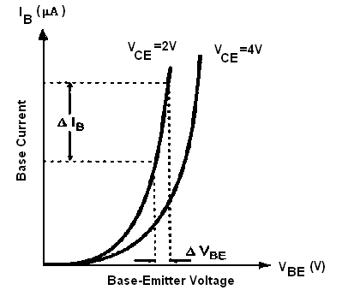
Input Characteristics of a Transistor in CB Configuration

Table for Input Characteristics:

S.No | VCE = 2V |  | VCE = 4V
S.No | VBE(volts) | IB (µA) | VBE(volts) | IB (µA)
1

2

3

4

5

6

7

YARTHIPLUS.COM

From this characteristic we observe the following important points.

- As the input to a transistor in the CE configuration is between the

base-to-emitter junctions, the CE input characteristics resembles a

family of forward-biased diode curves.

2. After the cut-in voltage (barrier potential, normally 0.7 V for silicon and 0.3 V for Germanium), the base current (IB) increases rapidly with small increase in emitter-base voltage (VEB). It means that input resistance is very small. Because input resistance is a ratio of change in emitter-base voltage (∆VEB) to the resulting changes in base current (∆IB) at constant collector-emitter voltage (VCE), this resistance is also known as the dynamic input resistance of the transistor in CE configuration.
3. For a fixed value of VBE, IB decreases as VCE is increased. A larger value of VCE results in a large reverse bias at collector-base p-n junction. This increases the depletion region and reduces the effective width of the base. Hence, there are fewer recombinations in the base region, reducing the base current IB.

OUTPUT CHARACTERISTICS: PROCEDURE:

1. Connections are given as per the circuit diagram.
2. The supply is switched ON.
3. The base current IB is kept constant.

4. By varying the collector-emitter voltage VCE, the various collector current IC is noted.
5. The same procedure is repeated for various base current IB.

6. The output characteristic is the curve between collector current IC and collector emitter voltage VCE at constant base current IB. The collector current is taken along Y-axis and collector-emitter voltage magnitude along X-axis.

YARTHIPLUS.COM

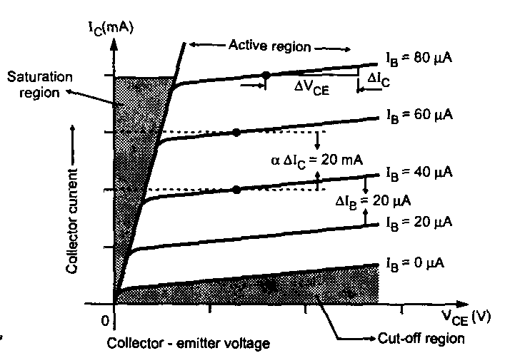
Output Characteristics of a Transistor in CB Configuration

Table for Output Characteristics:

S.No | IB = 0 µA |  | IB = 20 µA |  | IB = 40 µA
S.No | VCE(volts) | IC (mA) | VCE(volts) | IC (mA) | VCE(volts) | IC (mA)
1

2

3

4

5

6

7

WW.VIDYARTHIPLUS.COM
From the output characteristics we can see that,

1. The change in collector-emitter voltage (∆VCE) causes the little change in

the collector current (∆IC) for constant base current IB.

2. The output characteristic of common emitter configuration consists of three regions: Active, Saturation, and cut-off.
3. Active region: The region where the curves are approximately horizontal is the “active” region of the CE configuration. In the active region, the collector junction is reverse biased. As VCE is increased, reverse bias increases. This causes depletion region to spread more in base than in collector, reducing the chances of recombination in the base.
4. Saturation region : If VCE is reduced to a small value such as 0.2 V, then collector-base junction becomes forward biased, since the emitter base junction is already forward biased by 0.7 V. The input junction in CE configuration is base to emitter junction, which is always forward biased to operate transistor in active region. Thus input characteristics of CE configuration are similar to forward characteristics of p-n junction diode. When both the junctions are forward biased, the transistor operates in the saturation region, which is indicated on the output characteristics. The saturation value of VCE, designated VCE (sat) usually ranges between 0.1 V to 0.3 V.
5. Cut-off region: When the input base current is made equal to zero, the collector current is the reverse leakage current. Accordingly, in order to cut-off the transistor, it is not enough to reduce IB = 0. Instead, it is necessary to reverse bias the emitter junction slightly. We shall define cut-off as the condition where the collector current is equal to reverse saturation current and the emitter current is zero.

RESULT:

Thus the input and output characteristics of a bipolar junction transistor in

common emitter configuration is analyzed.
DYARTHIPLUS.COM

EX. NO : 8 CHARACTERISTICS OF BJT IN CB CONFIGURATION AIM:
To plot the input and output characteristics of a bipolar junction transistor (BJT) in common base (CB) configuration.

APPARATUS REQUIRED:

S.NO | APPARATUS | RANGE | QUANTITY
1 | RPS | (0-30)V | 2
2 | Resistor | 1KΩ | 2
3 | DC Voltmeter | (0-30)V | 2
4 | DC Ammeter | (0-10)mA | 1
5 | DC Ammeter | (0-30)mA | 1
6 | BJT | BC547 | 1
7 | Bread board | - | 1
8 | Connecting wires | - | Few

THEORY:

Pin Diagram of BJT Symbol of BJT

WWW.VIDYARTHIPLUS.COM V+ TEAM
WWW.VIDYARTHIPLUS.COM

INPUT CHARACTERISTICS:

PROCEDURE:

1. Connections are given as per the circuit diagram. 2. The supply is switched ON.
3. The collector-base voltage VCB is kept constant.

4. By varying the emitter-base voltage VEB, the various emitter current IE is noted.
5. The same procedure is repeated for various collector-base voltages VCB.
6. The input characteristic is the curve between input current IE and input voltage VEB at constant collector-base voltage VCB. The emitter current is taken along Y-axis and emitter base voltage along X-axis.

.COM

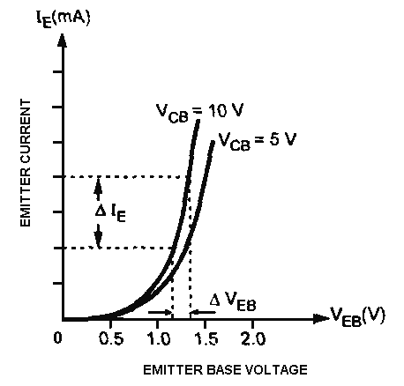
Input Characteristics of a Transistor in CB Configuration

Table for Input Characteristics:

S.No | VCB = 5V |  | VCB = 10V
S.No | VEB(volts) | IE (mA) | VEB(volts) | IE (mA)
1

2

3

4

5

From this characteristic we can observe the following important points:

WWW.VIYARTHIPLUS.COM

OUTPUT CHARACTERISTICS: PROCEDURE:

1. Connections are given as per the circuit diagram.

2. The supply is switched ON.

3. The emitter current IE is kept constant.

4. By varying the collector-base voltage VCB, the various collector current IC is noted.
5. The same procedure is repeated for various emitter current IE.

6. The output characteristic is the curve between collector current IC and collector base voltage VCB at constant emitter current IE. The collector current is taken along Y-axis and collector-base voltage magnitude along X-axis.

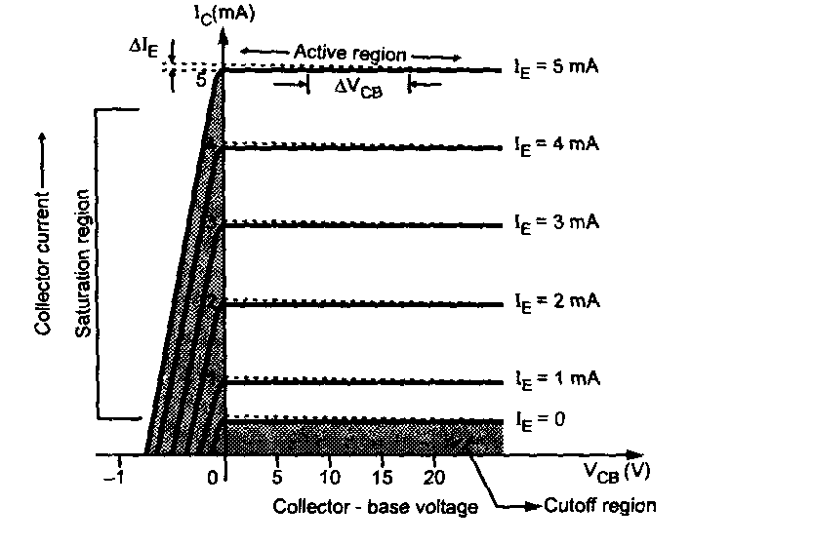

ARTHIPLUS.COM

Output Characteristics of a Transistor in CB Configuration

Table for Output Characteristics:

S.No | IE = 0 mA |  | IE = 2 mA |  | IE = 4 mA
S.No | VBC(volts) | IC (mA) | VBC(volts) | IC (mA) | VBC(volts) | IC (mA)
1

2

3

4

5

From this characteristics we observe following points

WWW.VIDYARTHIPLUS.COM V+ TEAM
WWW.VIDYARTHIPLUS.COM

1. The output characteristic has three basic regions: Active, cut-off and saturation.

State | Emitter Base Junction | Collector Base Junction
Active | Forward Biased | Reverse Biased
Cut-off | Reverse Biased | Reverse Biased
Saturation | Forward Biased | Forward Biased

2. In active region, IC is approximately equal to IE and transistor works as an amplifier.
3. The region below the curve IE = 0 is called as cut-off region.

4. The saturation region is that region of the characteristics which is to the left of VCB =0 V. The exponential increase in collector current as the voltage VCB increases towards 0 V.
5. As IE increases IC also increases. Thus, IC depends upon input current IE but not on collector voltage. Hence, input current controls output current. Since transistor requires some current to drive it, it is called current operating device.

RESULT:

Thus the input and output characteristics of a bipolar junction transistor in

common base configuration is analyzed.
COM

CHARACTERISTICS OF SCR

EX. NO: 9(a)

AIM:

To study and plot the forward and reverse characteristics of silicon controlled rectifier (SCR).

APPARATUS REQUIRED:

S.NO | APPARATUS | RANGE | QUANTITY
1 | RPS | (0-30)V | 2
2 | Resistor | 1KΩ | 2
3 | DC Voltmeter | (0-10)V | 1
4 | DC Ammeter | (0-30)mA | 2
5 | DC Ammeter | (0-3)mA | 1
6 | SCR | 2P4M | 1
7 | Bread board | - | 1
8 | Connecting wires | - | Few

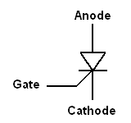
THEORY:

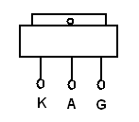
Pin Diagram of SCR Symbol of SCR

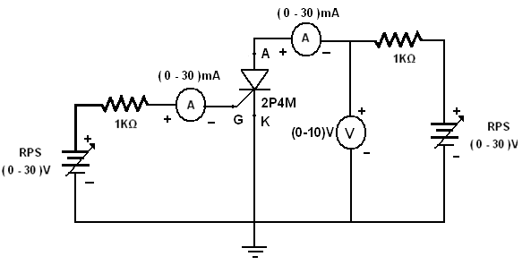

FORWARD CHARACTERISTICS:HIPLUS.COM

PROCEDURE:

1. Connections are given as per the circuit diagram.
2. The supply is switched ON.
3. Set the gate current I_{G} equal to firing current.

4. Vary the anode to cathode voltage (V_{AK}) and note down the corresponding anode current I_{A}. Note that the V_{AK} suddenly drops and there is a sudden increase in the I_{A}.
5. Repeat the above procedure for various gate current I_{G}. 6. Plot the graph between V_{AK} and I_{A}.

REVERSE CHARACTERISTICS:
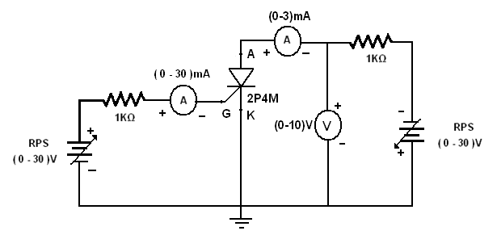

WW.VIDYWW.VIDYARTHIPLUS.COM

PROCEDURE:

1. Connections are given as per the circuit diagram.
2. The supply is switched ON.
3. Set the gate current I_{G} equal to firing current.

4. Vary the anode to cathode voltage (V_{AK}) and note down the corresponding anode current I_{A}. Note that the I_{A} is negligibly small and practically it is neglected.
5. Repeat the above procedure for various gate current IG. 6. Plot the graph between V_{AK} and I_{A}.

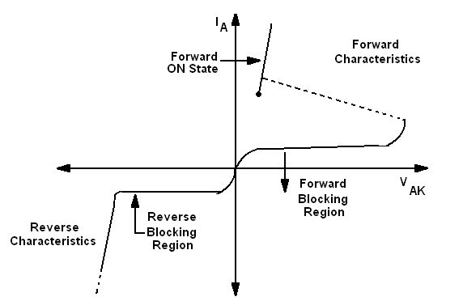

Characteristics of a SCRYARTHIPLUS.COM

Table:

S.No | Forward Bias |  | Reverse Bias
S.No | IG = 25mA |  | IG = 25mA
S.No | VAK(volts) | IA (mA) | VAK(volts) | IA (mA)
1

2

3

4

5

6

7

RESULT:

Thus the forward and reverse characteristics of a silicon controlled rectifier are analyzed.
VIDYARTHIPLUS.COM

CHARACTERISTICS OF UJT

EX. NO : 9(b)

AIM:

To study and plot the characteristics of uni junction transistor (UJT) and to determine the peak voltage (V_{P}), valley point voltage (V_{V}), valley point current (I_{V}) and intrinsic standoff ratio (η).

APPARATUS REQUIRED:

S.NO | APPARATUS | RANGE | QUANTITY
1 | RPS | (0-30)V | 2
2 | Resistor | 1KΩ | 1
3 | Resistor | 220Ω | 1
3 | DC Voltmeter | (0-30)V | 2
5 | DC Ammeter | (0-100)mA | 1
6 | UJT | 2N2646 | 1
7 | Bread board | - | 1
8 | Connecting wires | - | Few

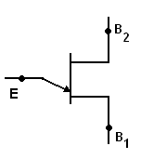
THEORY:

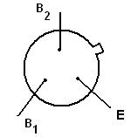
Pin Diagram of UJT Symbol of UJT

The UJT is essentially a bar of N type semiconductor material into which P

type material has been diffused somewhere along its length.ARTHIPLUS.COM

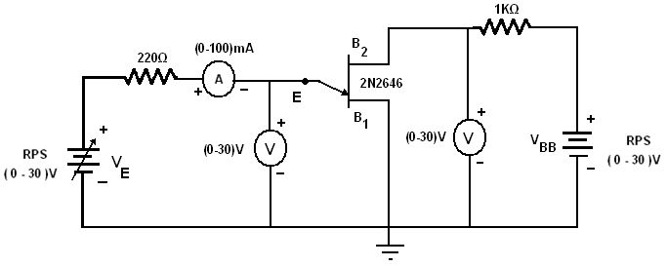

PROCEDURE:

1. Connections are given as per the circuit diagram.

2. The supply is switched ON.

3. Set the voltage across base 1 and base 2 (V_{BB}) is constant.

4. Vary the voltage across emitter and base 1 (V_{E}) and note down the emitter current (I_{E}).
5. Repeat the above procedure for various VBB. 6. Plot the graph between V_{E} and I_{E}.
7. From the plot determine the Table:

S.No | VBB = 5V |  | VBB = 5V
S.No | VE(volts) | IE (mA) | VE(volts) | IE (mA)
1

2

3

4

5

6

WWW.VIDYARTHIPLUS.ARTHIPLUS.COM

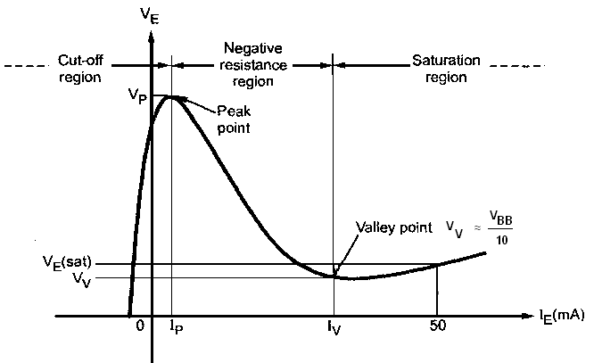
Characteristics of a UJT

The characteristics can be divided into three main regions which are,

1. Cut-off region: The emitter voltage V_{E} is less than V_{P} and the p-n junction is reverse biased. A small amount of reverse saturation current flows through the device, which is negligibly small of the order of µA. This condition remains till the peak point.
2. Negative resistance region: When the emitter voltage V_{E} becomes equal to V_{P} the p-n junction becomes forward biased and I_{E} starts flowing. The voltage across the device decreases in this region, though the current through the device increases. Hence the region is called negative resistance region. This region continues till valley point.
3. Saturation region: Increase in I_{E} further valley point current I_{V} drives the device in the saturation region. The voltage corresponding to valley point is called valley point voltage denoted as V_{V} In this region; further decrease in voltage does not take place. The characteristic is similar to that of a semiconductor diode, in this region.
From the plot,PLUS.COM

- V_{P}=
(ii) V_{V} = (iii) I_{V} =
(iv) η = (V_{P} – V_{D}) / V_{BB} =

Where V_{D} = The diode drop
= 0.3 to 0.7 V

RESULT:

Thus the characteristic of a Uni Junction Transistor(UJT) is analyzed and

the peak voltage (V_{P}), valley point voltage (V_{V}), valley point current (I_{V}) and

intrinsic standoff ratio (η) are determined.

ARTHIPLUS.COM
CHARACTERISTICS OF JFET

EX. NO: 10(a)

AIM:

To plot the drain and transfer characteristics of a Junction Field Effect Transistor (JFET) and to calculate the transconductance (gm), drain to source resistance (rd), amplification factor (µ).
APPARATUS REQUIRED:

S.NO | APPARATUS | RANGE | QUANTITY
1 | RPS | (0-30)V | 2
2 | Resistor | 220Ω | 2
3 | DC Voltmeter | (0-10)V | 1
4 | DC Voltmeter | (0-30)V | 1
5 | DC Ammeter | (0-30)mA | 1
6 | JFET | BFW11 | 1
7 | Bread board | - | 1
8 | Connecting wires | - | Few

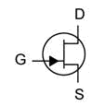
THEORY:

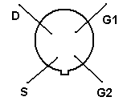
N-channel JFET Pin Diagram

The JFET is a long channel of semiconductor material, doped to contain abundance of positive charge carriers (p-type), or of negative carriers (n-type). Contacts at each end form the source and drain. The gate (control) terminal has doping opposite to that of the channel, which it surrounds, so that there is a P-N junction at the interface. Terminals to connect with the outside are usually made Ohmic .VIDYARTHIPLUS.COM

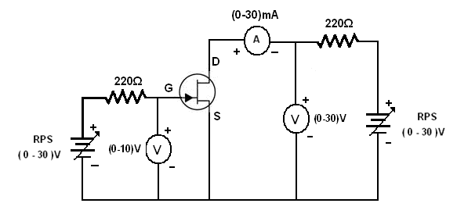
The flow of electric charge through a JFET is controlled by constricting the current-carrying channel. The current depends also on the electric field between source and drain.

Circuit Diagram for JFET

DRAIN CHARACTERICTICS:

PROCEDURE:

1. Connections are given as per the circuit diagram.

2. The supply is switched ON.

3. The gate-source voltage V_{GS} is kept constant.

4. By varying the drain-source voltage V_{DS}, the various drain current I_{D} is noted.
5. The same procedure is repeated for various gate-source voltage V_{GS}.

VIDYARTHIPLUS.COM

Table for Drain Characteristics:

S.No | V_{GS} = 0.5V |  | V_{GS} = 1V
S.No | I_{D} (mA) | V_{DS}(volts) | I_{D} (mA) | V_{DS}(volts)
1

2

3

4

5

6

7

WWW.VIDYARTHIPLUS.COW.VIDYARTHIPLUS.COM

TRANSFER CHARACTERISTICS: PROCEDURE:
1. Connections are given as per the circuit diagram.

2. The supply is switched ON.

3. The drain-source voltage V_{DS} is kept constant.

4. By varying the gate-source voltage V_{GS}, the various drain current I_{D} is noted.
5. The same procedure is repeated for various drain-source voltage V_{DS}.ARTHIPLUS.COM

Table for Transfer Characteristics:

S.No | V_{DS} = 2V |  | V_{DS} = 4V
S.No | V_{GS}(volts) | I_{D} (mA) | V_{GS}(volts) | I_{D} (mA)
1

2

3

4

5

6

7

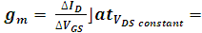
The transconductance is,

The drain to source resistance is,

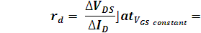
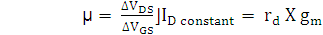
The Amplification factor is,

=

RESULT:

Thus the drain and transfer characteristics of a junction field effect transistor is analyzed and the transconductance (gm), drain to source resistance (rd), amplification factor (µ) are calculated.
DYARTHIPLUS.COM

CHARACTERISTICS OF MOSFET

EX. NO : 10(b) AIM:
To plot the drain and transfer characteristics of a n-channel depletion type Metal Oxide Semiconductor Junction Field Effect Transistor (MOSFET).
APPARATUS REQUIRED:
S.NO | APPARATUS | RANGE | QUANTITY
1 | RPS | (0-30)V | 2
2 | Resistor | 220Ω | 2
3 | DC Voltmeter | (0-10)V | 1
4 | DC Voltmeter | (0-30)V | 1
5 | DC Ammeter | (0-30)mA | 1
6 | MOSFET |  | 1
7 | Bread board | - | 1
8 | Connecting wires | - | Few

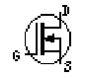
THEORY:

N-channel JFET
1.The metal–oxide–semiconductor field-effect transistor (MOSFET, MOS-FET,
or MOS FET) is a device used to amplify or switch electronic signals.
2.The MOSFET differs from JFET in that it has no p-n junction structure.
Instead, the gate of the MOSFET insulated from the channel by a silicon dioxide
(SiO2) layer. Due to this the input resistance of MOSFET is greater than JFET.

.VIDYARTHIPLUS.COM

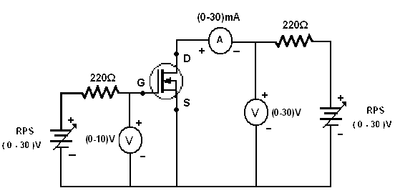
Circuit Diagram for MOSFET DRAIN CHARACTERICTICS:
PROCEDURE:

1. Connections are given as per the circuit diagram.

2. The supply is switched ON.

3. The gate-source voltage V_{GS} is kept constant.

4. By varying the drain-source voltage V_{DS}, the various drain current I_{D} is noted.
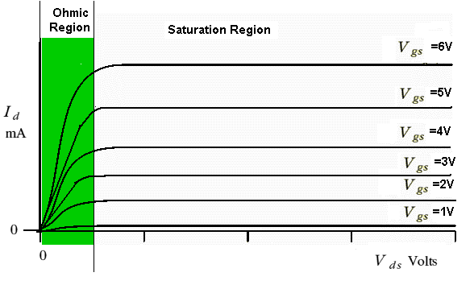
5. The same procedure is repeated for various gate-source voltage V_{GS}.

WWW.VIDYARTHIPLUVIDYARTHIPLUS.COM

Table for Drain Characteristics:

S.No | V_{GS} = |  | V_{GS} =
S.No | I_{D} (mA) | V_{DS}(volts) | I_{D} (mA) | V_{DS}(volts)
1

2

3

4

5

6

7

TRANSFER CHARACTERISTICS: PROCEDURE:
1. Connections are given as per the circuit diagram.

2. The supply is switched ON.

3. The drain-source voltage V_{DS} is kept constant.

4. By varying the gate-source voltage V_{GS}, the various drain current I_{D} is noted.
5. The same procedure is repeated for various drain-source voltage V_{DS}.
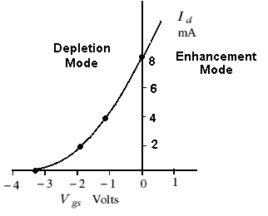
DYARTHIPLUS.COM

For positive values of VGS the positive gate will draw additional electrons from the p-type substrate due to reverse leakage current and establish new carries through the collisions between accelerating particles. Because of this, as gate to source voltage increases in positive direction, the drain current also increases.

Table for Transfer Characteristics:

S.No | V_{DS} = |  | V_{DS} =
S.No | V_{GS}(volts) | I_{D} (mA) | V_{GS}(volts)  ) | I_{D} (mA)
1

2

3

4

5

6

RESULT:

Thus the drain and transfer characteristics of a metal oxide semiconductor junction field effect transistor is analyzed.

LUS.COM

CHARACTERISTICS OF DIAC

EX. NO: 11(a)

AIM:
To plot the V-I characteristics of a DIAC.
APPARATUS REQUIRED:

S.NO | APPARATUS | TYPE | QUANTITY
1 | RPS | (0-30)V | 1
2 | Resistor | 1KΩ | 1
3 | DC Voltmeter | (0-30)V | 1
5 | DC Ammeter | (0-30)mA | 1
6 | DIAC |  | 1
7 | Bread board | - | 1
8 | Connecting wires | - | Few

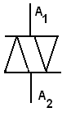
THEORY:

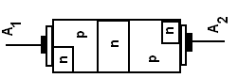
Construction Symbol

WWW.VIDYARTHIPLUS.COM

FORWARD BIAS:

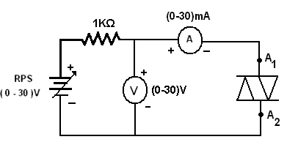
PROCEDURE:

1. Connections are given as per the circuit diagram. 2. The supply is switched ON.
3. Vary the power supply in regular step and note down the voltage and current of DIAC.
4. Plot the graph between the voltage and current.

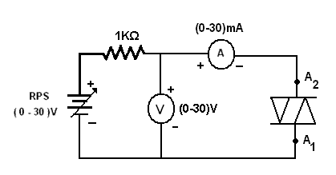

REVERSE BIAS:

IDYARTHIPLUS.COM

PROCEDURE:

1. Connections are given as per the circuit diagram.

2. The supply is switched ON.

3. Vary the power supply in regular step and note down the voltage and current of DIAC.
4. Plot the graph between the voltage and current.

Table:

S.No | FORWARD BIAS |  | REVERSE BIAS
S.No | Voltage(V) | Current(mA) | Voltage(V) | Current(mA)
1

2

3

4

5

6

7

8

9

10

DYARTHIPLUS.COM

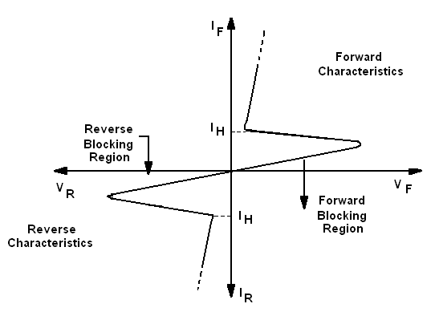

RESULT:

Thus the V-I characteristics of a DIAC is analyzed.

W.VIDY.VIDYARTHIPLUS.COM

CHARACTERISTICS OF TRIAC

EX. NO : 11(b)

AIM:

To plot the V-I characteristics of a TRIAC. APPARATUS REQUIRED:

S.NO | APPARATUS | TYPE | QUANTITY
1 | RPS | (0-30)V | 2
2 | Resistor | 10 KΩ  5 KΩ | 1  1
3 | DC Voltmeter | (0-30)V | 1
5 | DC Ammeter | (0-100)mA | 2
6 | TRIAC | BT136 | 1
7 | Bread board | - | 1
8 | Connecting wires | - | Few

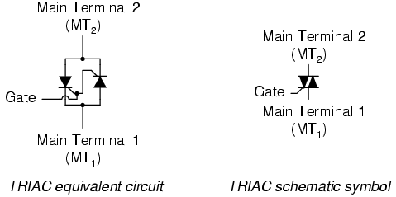
:

WWW.VIDYARTHIPLUS.COM

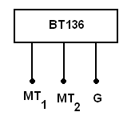
Pin Diagram

It is basically two SCR’s turned in opposite directions, with a common gate terminal. It is a bidirectional device. The two main electrodes are called MT1 and MT2 while common control terminal is called gate G. S The gate terminal is near to MT1. The triac can be turned ON by applying either positive or negative voltage to the gate G with respect to the main terminal MT1.
FORWARD BIAS:

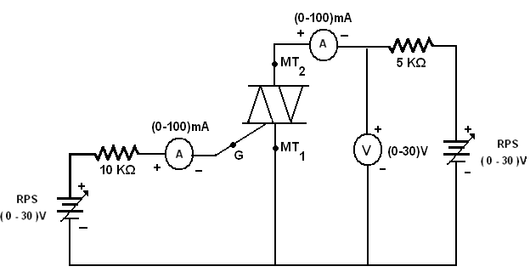

WWW.VIDYARW.VIDYARTHIPLUS.COM

PROCEDURE:

1. Connections are given as per the circuit diagram.

2. The supply is switched ON.

3. The Gate current IG is set to 2mA by varying the RPS which connected to the gate.
4. Vary another power supply which is connected across the terminals of TRIAC in regular step and note down the voltage and current of TRIAC.
5. Plot the graph between the voltage and current.

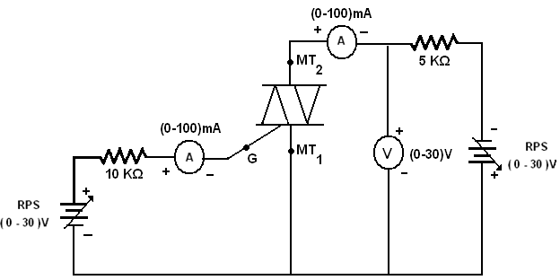

REVERSE BIAS:

WWW.VIDYARTHIPLUS.COM V+ TEAM
WWW.VIDYARTHIPLUS.COM

PROCEDURE:

1. Connections are given as per the circuit diagram.

2. The supply is switched ON.

3. The Gate current IG is set to 2mA by varying the RPS which connected to the gate.
4. Vary another power supply which is connected across the terminals of TRIAC in regular step and note down the voltage and current of TRIAC.
5. Plot the graph between the voltage and current.

Table:
S.No | FORWARD BIAS |  | REVERSE BIAS
S.No | Gate Current (IG= 2mA) |  | Gate Current (IG= 2mA)
S.No | Voltage(V) | Current(mA) | Voltage(V) | Current(mA)
1

2

3

4

5

6

7

8

9

10

WWW.VIDYARTHIPLUS.COM V+ TEAM
WWW.VIDYARTHIPLUS.COM

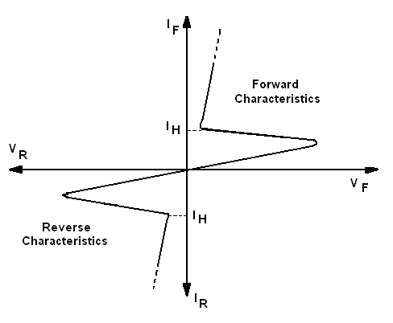
V-I characteristics of a TRIAC

RESULT:

Thus the V-I characteristics of a TRIAC is analyzed.

THIPLUS.COM

CHARACTERISTICS OF PHOTO DIODE

EX. NO: 12(a)

AIM:
To plot the characteristics of a Photo Diode.

APPARATUS REQUIRED:

S.NO | APPARATUS | TYPE | QUANTITY
1 | RPS | (0-30)V | 1
2 | Resistor | 1KΩ | 1
3 | DC Voltmeter | (0-30)V | 1
4 | DC Ammeter | (0-50)mA | 1
5 | Photo Diode |  | 1
6 | Bread board | - | 1
7 | Connecting wires | - | Few

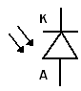
THEORY:

Symbol

The photodiode is a semiconductor p-n junction device whose region of

operation is limited to the reverse biased region.

The reverse current without light in diode is in the range of µA. The change in this current due to the light is also in the range of µA. Thus such a change can be significantly observed in the reverse current. If the photodiode is forward biased, the current flowing through it is in mA. The applied forward biased voltage takes the control of the current instead of the light. The change in forward current due to light is negligible and cannot be noticed. The resistance of forward biased diode is not affected by the light. Hence to have significant effect of light on the current and to operate photodiode as a variable resistance device, it is always connected in reverse biased condition.DYARTHIPLUS.COM

The depletion region width is large. Under normal condition, it carries small reverse current due to minority charge carriers. When light is incident through glass window on the p-n junction, photons in the light bombarding the p-n junction and some energy is imparted to the valence electrons. Due to this, valence electrons are dislodged from the covalent bonds and become free electrons. Thus more electron-hole pairs are generated. Thus total number of minority charge carriers increases and hence the reverse current increases.
When there is no light, the reverse biased photodiode carries a current which is very small and called dark current. It is purely due to thermally generated minority carriers. When light is allowed to fall on a p-n junction through a small window, photons transfer energy to valence electrons to make them free. Hence reverse current increases. It is proportional to the light intensity. The reverse current is not dependent on reverse voltage and totally depends on light intensity.

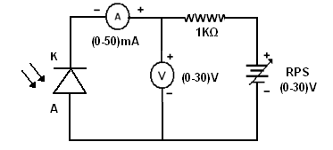
PROCEDURE:

1. Connections are given as per the circuit diagram.

2. Connect the patch card from one of the devices mounted in the moving plot to the main unit.
3. Connect the unit to the 220V supply. Switch ON the toggle switch. LED will glow that indicating that the unit is ready for operation.
4. Connect the mains card of the light source to 220V AC supply and switch ON the controller.
5. Adjust the distance between the light source and photo diode. Note down the current and voltage for various distances..VIDYARTHIPLUS.COM

6. Plot the graph between the reverse voltage and reverse current.

Table:

S.No | Distance(mm) | Voltage(V) | Current(mA)
1

2

3

4

5

6

7

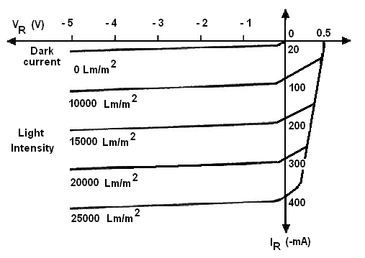
Photo Diode Characteristics

RESULT:

Thus the characteristic of a photo diode is analyzed.

RTHIPLUS.COM

CHARACTERISTICS OF PHOTO TRANSISTOR

EX. NO: 12(b)

AIM:

To plot the characteristics of a photo transistor. APPARATUS REQUIRED:
S.NO | APPARATUS | TYPE | QUANTITY
1 | RPS | (0-30)V | 1
2 | Resistor | 1KΩ | 1
3 | DC Voltmeter | (0-30)V | 1
4 | DC Ammeter | (0-50)mA | 1
5 | Photo Transistor |  | 1
6 | Bread board | - | 1
7 | Connecting wires | - | Few

THEORY:

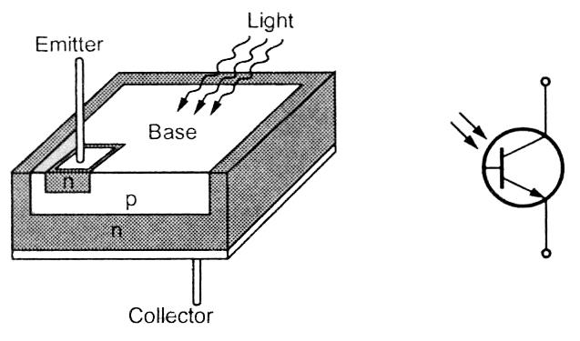
C

E

Construction Symbol

The phototransistor has a light sensitive collector to base junction. A lens is used in a transistor package to expose base to an incident light. When no light is incident, a small leakage current flow from collector to emitter due to small
ARTHIPLUS.COM

thermal generation. This is very small current, of the order of nA. This is called a dark current. When the base is exposed to the light, the base current is produced which is proportional to the light intensity.

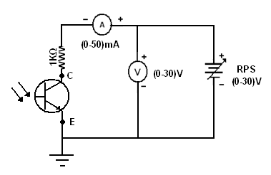
PROCEDURE:

1. Connections are given as per the circuit diagram.

2. Connect the patch card from one of the devices mounted in the moving plot to the main unit.
3. Connect the unit to the 220V supply. Switch ON the toggle switch. LED will glow that indicating that the unit is ready for operation.
4. Connect the mains card of the light source to 220V AC supply and switch ON the controller.
5. Adjust the distance between the light source and photo transistor. Note down the collector current (IC) and voltage between collector and emitter (VCE) for various distances.
6. Plot the graph between the collector current (IC) and voltage between collector and emitter (VCE).

Table:

S.No | Distance(mm) | VCE(V) | IC(mA)
1

2

3

4

5

6

7

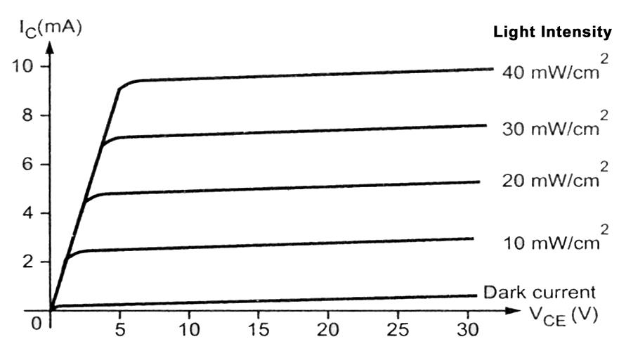
Photo Transistor Characteristics

RESULT:

Thus the characteristics of a photo transistor are analyzed.

